Night Time Treasure Hunt at Thingamajigs
Outdoor treasure hunt in the dark
Prizes to be won!
Don’t forget to bring your torch.
We will be serving pizza and drinks!
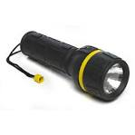
Thursday 30th November 2017
3-30pm - 5-30pm
At £10 per child
Please book your place with Miss Lawrence ASAP

